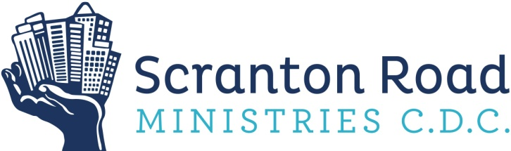

3095 Scranton Rd.
Cleveland, OH 44113

Phone: (216) 861-5323 | Fax: (216) 861-7524

www.scrantonroadministries.org

Scranton Road Legal Clinic

Service Area: Greater Cleveland (focus on near west side neighborhoods)

Financial Qualification: Currently no requirements; $20 suggested donation/administrative fee (not mandatory)

Times Available: Brief Advice is available by appointment only by calling (216) 861-5323 or e-mailing legalclinic@scrantonroadministries.org.
Ask for SRLC Director Sheila Fell or Staff Attorney Leigh Prugh.

Brief Advice Provided for: Wills, Powers of Attorney, Living Wills, Visitation, Custody, Child Support, Expungement/CQE, Guardianship, Landlord/Tenant, Debtor/Creditor, Contracts, Consumer, Creditor/Debtor, Dissolution/Divorce/Separation, Small Claims, and more
Workshop Topics: Wills, Powers of Attorney, Living Wills, Guardianship, Expungement/CQE, Visitation/Custody, Child Support, Divorce/Dissolution, Debtor/Creditor, Landlord/Tenant, Special Education, Foreclosure Resources, Student Loans, and more

Brief Advice Sessions are conducted with licensed attorneys. Participants can discuss their rights, responsibilities, and options for moving forward. Assistance with pro se paperwork is provided. Referrals to low cost/pro bono attorneys may be provided if advisable and available. We do not provide legal representation. We do not provide advice for criminal or immigration cases.

Workshops are conducted in collaboration with local nonprofit organizations and are for educational purposes. Opportunities for Q&A and assistance with paperwork will be provided.

While the Scranton Road Legal Clinic is a faith-based organization, we do not limit our services to any race, color, sex, sexual orientation, age, national origin, or religion.

