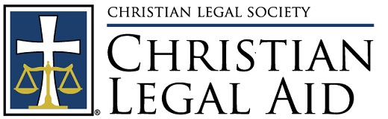

Christian Legal Aid Clinic
Initial Startup Steps

- Initial recruitment & vision-casting

  - Get the word out about plan to create Christian legal aid clinic.
  - Cast a wide net:
    - Local CLS chapter members
    - Larger churches
    - Ask everyone to share with their contacts
  - Organize an initial interest meeting of attorneys and non-attorneys, including church leaders, to learn what Christian Legal Aid is all about.

- Find a core group of volunteers

  - At least 3-4 attorneys willing to start
  - And 2-3 non-attorneys to help with logistical issues
  - Starting goal is to find a team of volunteers who buy into the vision and are committed enough to be the core members in starting a program.
    - The core can serve as the initial board of directors in new nonprofit organization.

- Find a church or other ministry in the area that is excited about the idea. Usually churches/organizations that already have some kind of service to needy people are more naturally interested. Ideally, the church/organization should be committed to being an equal partner in the endeavor, not merely offering space. Obtain commitment of host church or organization to provide:

  - At least one person to champion the cause w/in the organization
  - Support of pastor/leader
  - Ideally, organization would provide donation of some staff time
  - Space to hold clinics (e.g. Sunday school classrooms)
  - At least one person to do client intakes
  - Several other volunteers to do other administrative tasks
  - Help in recruiting attorneys
  - Help in raise financial support

- Determine plans for:

  - Clinic session logistics, make sure host organization can accommodate
  - Client advertising
  - Client intake procedure
  - Scheduling of attorneys and other volunteers
  - Client records maintenance

