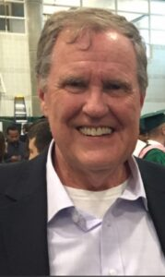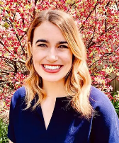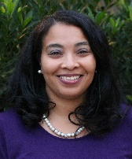

FEBRUARY 2- 4, 2024

* All prices based on double occupancy.
* Registration Deadline: January 22, 2024
* Hotel-style facilities
* Scholarships Available
* Transportation Available
* New Feature: Law Student Panel (Saturday)

**$218**

NON-ATTORNEY/

SPOUSE

**$262**

ATTORNEY

**$145**

LAW STUDENT

**$44**

**CHILD**

ANNIE BECKER

LAKUITA BITTLE

STEVE DENNY

KELLYE FABIAN STORY

***"Walking in a Manner Worthy of the Calling to Which You Have Been Called"***

***Ephesians 4:1***

CONFERENCE POINT CENTER (SODERQUIST LODGE) – LAKE GENEVA, WI

For more information, contact Brent Amato (amatos1@comcast.net) or Lakuita Bittle (lbittle@clsnet.org)

REGISTER TODAY AT CHRISTIANLEGALSOCIETY.ORG/EVENTS

**2024 CLS REGIONAL RETREAT   
MIDWEST**