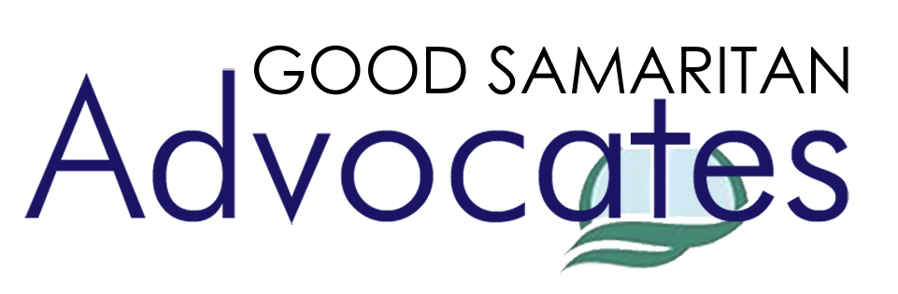
Disclosure, Consent, and Waiver

I understand that a volunteer attorney(s) associated with Good Samaritan Advocates (“GSA”) has agreed to provide me with an interview, advice, and possible referral to others at a GSA clinic. Although GSA has arranged the interview, I understand that the Attorney(s) is acting solely on his or her behalf and not on behalf of GSA or the church in which the interview is taking place. I understand that the Attorney(s) is not obligated to take any action on my behalf after this interview. I understand that if I wish to be represented by an attorney, I may seek help from a legal aid society, a public defender, or an attorney in private practice.

I consent to GSA and any attorney or other person who has interviewed me, and any of their agents, to discuss my matter or view my file to provide or evaluate advice, referral or service, or for statistical or research purposes.

In exchange for receiving an interview at this GSA clinic, I RELEASE and/or WAIVE claims of any kind that I may have against GSA, Christian Legal Society, Columbia Baptist Church, Reston Bible Church, Covenant Life Church, or any of their affiliates or agents that may arise out of or be related to the advice, referral, or service that I receive at this GSA clinic.

Client Signature: Date:

Printed Name:

Witness Signature: Date:

Printed Name:

